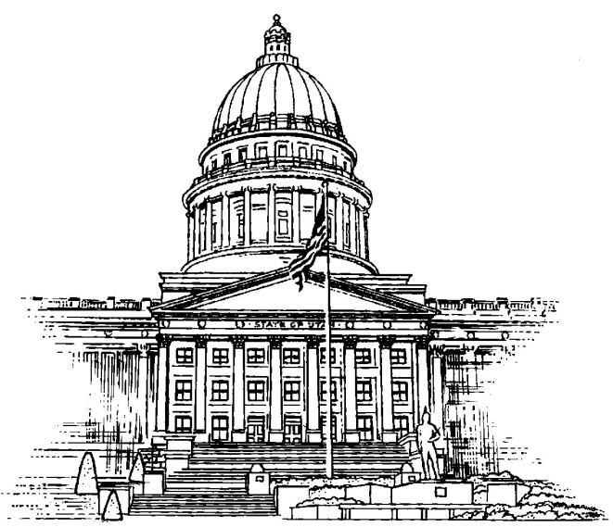

Independent Legislative Ethics Commission

2018 Summary Data Report to
the Utah Legislature

Independent Legislative Ethics Commission
Commission Chair: Judge Hans Q. Chamberlain
Executive Director: Kim J. Bouck
PO Box 142325
Salt Lake City, Utah 84114
Phone: (801) 326-1422

Purpose of the Report
The Summary Data Report to the Utah Legislature was prepared in accordance with JR6-2-104. This rule requires the Independent Legislative Ethics Commission to prepare an annual report of the Commission’s activities, including the following:

- A general description of the activities of the Commission during the past year
- Statistical information for ethical complaints
- An accounting of the Commission’s budget and expenditures

General Description of Activities
The Commission held its annual meeting on January 8, 2018. At that meeting, Mr. David Clark, Judge Gordon Low and Judge Michael Lyon were sworn in as Commission members. Mr. David Clark was voted in the Chair Pro Tempore.

The 2018 Commission membership is as follows:
Judge Hans Chamberlain, Chair
Mr. David Clark, Chair Pro Tempore
Judge Michael Lyon
Ms. LaWanna “Lou” Shurtliff
Judge Gordon J. Low

Statistical Information for Ethical Complaints
During 2018, the number of ethical complaints filed with the commission is as follows:

- The number of ethics complaints filed with the commission: 1
- The number of complaints filed against a member of the House of Representatives: 1
- The number of complaints filed against a member of the Senate: 0

The ethical complaint that was filed against a member of the House of Representatives was returned for non-compliance with JR6-3-101. In 2018, the Ethics Commission did not recommend review of any complaints by the Legislative Ethics Committees.

Accounting of Commission’s Budget and Expenditures
In 2018, the following expenditures were paid out of the Legislative Ethics Commission’s budget:

$4000 – Executive Director Salary

Total expenditures for 2018 - $4000.00

